caXchange Hub

caXchange – ScenPro, Inc.
Ekagra
Design Document

DOCUMENT CHANGE HISTORY
Version Number | Date | Contributor | Description
1.0 | 11/27/07 | Michael Holck | Initial Draft that describes the design of the elements included in the Elaboration phase
1.1 | 1/7/08 | Michael Holck | Added information describing the elaboration phase and construction phase I components
1.2 | 1/8/08 | Kalpesh S. Patel | Added caXchange Hub design information.
1.3 | 1/10/08 | Kalpesh S. Patel | Added Logging and Auditing design information.
1.4 | 1/17/08 | David Dorman | Update information presentation
1.5 | 2/05/08 | Amit Srivastava | Updated some information and diagrams


Updated Feb 05, 2008

TABLE OF CONTENTS
1.0 Background/Summary 1
2.0 Introduction 2
2.1 Overview 2
2.2 Scope 2
2.2.1 caXchange Hub 2
2.2.2 Common Logging Module Integration 2
2.3 Related Documentation 3
3.0 caXchange Design 4
3.1 caXchange Hub 4
3.1.1 Component View 4
3.1.2 Logical Design 5
3.1.2.1 caXchange Grid Service 5
3.1.2.2 caXchangeResponse Listener 5
3.1.3 Sequence Diagrams 8
3.1.3.1 Successful Flow Sequence Diagram 8
3.1.3.2 Rollback Flow Sequence Diagram 8
3.1.4 Data 9
3.1.5 Deployment 10
3.1.6 Test Cases and Scenarios 11
3.2 Common Logging Module Integration 11
3.2.1 Requirements 11
3.2.1.1 Trace Message Flow Through caXchange 11
3.2.1.2 Filter Messages to log by User 11
3.2.2 Component View 11
3.2.3 Local Design 12
3.2.4 Sequence Diagram 13
3.2.5 Data 14
3.2.6 Deployment 15
3.2.6.1 Sample servicemix.xml configuration 15
3.2.7 Test Cases and Scenarios 16
4.0 Glossary 17
LIST OF FIGURES
Figure 1 caXchange Component View 4
Figure 2 caXchange Response Listener 6
Figure 3 caXchange Successful Flow Sequence Diagram 8
Figure 4 caXchange Rollback Interaction Sequence Diagram 9
Figure 5 Database Table for caXchange Messages 10
Figure 6 caXchange Deployment Model 10
Figure 7 Component Model 11
Figure 8 CLM Integration Class Model 13
Figure 9 Logging and Auditing Successful Scenario Sequence Flow 14
Figure 10 Common Logging Module Integration Deployment Model 15
LIST OF TABLES
Table 1 caXchange Hub Related Documents 3
Table 2 caXchange Grid Service Operations 5
Table 3 caXchange Service Assembly Components 6
Table 4 ExchangeListener Interface Operations 12

Background/Summary
The overall goal of this project is to build a hub system that can be adapted and extended to multiple data formats and whose value and usability can be applied in one or more cancer centers. As the caBIG program is the primary sponsor, all work performed for this project must be done in compliance with the caBIG principles of open source, open development, open access, and federation. Software that is used and/or developed in the context of this project must be caBIG™ compatible at the silver level and be made available to the community through resources provided by the General Contractor.
(https://cabig.nci.nih.gov/guidelines_documentation/caBIGCompatGuideRev2_final.pdf

Introduction

Overview
This Design document captures the software design for only the software components of the caXchange version 1.0. The overall goal of this project is to build a hub system that can adapt and extend data to multiple formats and whose value and usability can be pilot tested in one or more cancer centers. This includes a cancer center hub client to submit laboratory data to CTODS as well as a Lab Viewer application to view this data. The Lab Viewer will be interoperable with other CCTS applications.

Scope
The scope of this document is limited to only the design of the caXchange components detailed in the following sections.

caXchange Hub
The caXchange Hub is the software component that is primarily responsible for receiving input from various external systems, routing the input to various services that are hosted on the hub, and eventually routing the output of those services to external systems. caXchange is implemented using Servicemix 3.1.2 enterprise service bus (ESB) for routing and exposing that functionality using a service deployed on caGrid. caXchange is deployed as a service assembly on Servicemix 3.1.2. caXchange grid service acts as a proxy to the service assembly.

Common Logging Module Integration
The Common Logging Module (CLM) provides the audit and logging services under caCORE set of tools. It includes a set of tools such as the log-locator web application. Integrating CLM with caXchange for logging enables the use of these tools for caXchange logs.

Related Documentation
For additional information on caXchange Hub, version 1.0, please refer to following documents:
Table 1 caXchange Hub Related Documents
Document | Version | Location
caXchange Use Case Specification and Realization Document | 1.0 | https://gforge.nci.nih.gov/plugins/scmcvs/cvsweb.php/caxchange/Deliverables/Use%20Case%20Specification%20and%20Realization%20Documents%20(Task%202.1).rtf?cvsroot=caxchange
caXchange Software Requirements Specification Document | 1.0 | https://gforge.nci.nih.gov/plugins/scmcvs/cvsweb.php/caxchange/Deliverables/Software%20Requirement%20Specifications%20(Task%202.2).doc?cvsroot=caxchange
caCORE 3.2_Tech_Guide (Chapter 10: Common Logging Module)
CSM – User Provisioning Tool User Guide |  | (ftp://ftp1.nci.nih.gov/pub/cacore/CSM/UPT_User_Guide.pdf)
Servicemix Documentation |  | http://servicemix.apache.org/documentation.html
Java Business Integration Specification |  | http://jcp.org/en/jsr/detail?id=208
caXchange Interface Specification |  | https://gforge.nci.nih.gov/plugins/scmcvs/cvsweb.php/caxchange/Documentation/Interface/caXchange_Interface_Specification.doc?cvsroot=caxchange
caXchange Design Diagram |  | https://gforge.nci.nih.gov/plugins/scmcvs/cvsweb.php/caxchange/Documentation/Design/reliable-messaging-diagram.odg?cvsroot=caxchange

caXchange Design
The design of the caXchange components are detailed in the following sections.

caXchange Hub

Component View
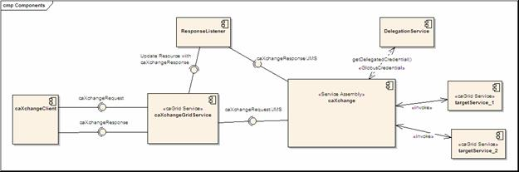
Figure 1 caXchange Component View
Figure 1 shows the high level components in caXchange. Please refer to the caXchange design diagram for the components within the caXchange service assembly.
- A caXchange client sends a caXchangeRequest message to caXchangeGridService.
- caXchangeGridService is a caGrid service which acts as a proxy for the caXchange service assembly deployed on Servicemix JBI (Java Business Integration) Container.
- caXchangeGridService creates a WS-Resourceframework Resource associated with the caXchangeRequest. This caXchangeRequest is then forwarded to the caXchange service assembly for processing. This is done by pushing caXchangeRequest message to the jms inbound component of caXchange service assembly.
- caXchange service assembly then invokes the DelegationService for the authorization credentials before routing the request message based on the message type. Please refer to the caXchange detailed design diagram for routing details.
- Outbound components then invoke the target services.
- Responses from the target services are then composed into a caXchangeResponse message.
- caXchangeResponse is then pushed to the jms outbound component.
- The response listener then picks up the caXchangeResponse and updates the WS-Resourceframework resource created in step 3.
- The caXchangeResponse is then available to the client.

Logical Design

caXchange Grid Service
The caXchange grid service acts as a proxy for caXchange. It forwards incoming requests to caXchange for processing. To keep track of a request it creates a WS-Resource framework resource. The grid service then returns an EndPointReference to the client. The client uses this end point reference to invoke the getResponse operation. The grid service also creates a response listener, which listens for caXchangeResponse and updates the resource. Please see the caXchange Interface Specification document for details of the operations it exposes.
Table 2 caXchange Grid Service Operations
Method | Notes | Parameters | Return
ProcessRequestAsynchronously | Process a caXchangeRequest | CaXchangeRequest | CaXchangeContextReference
getResponse | Gets the caXchangeResponse if it is ready, otherwise throws an Exception | None | caXchangeResponse

caXchangeResponse Listener
The caXchangeResponse listener lives with the caXchange Grid service. It listens for the response on the jms queue associated with the response outbound component of the caXchange service assembly. Once a response is received from the queue, the resource associated with the corresponding request is updated. The client can then use the getResponse method to get the caXchangeResponse.

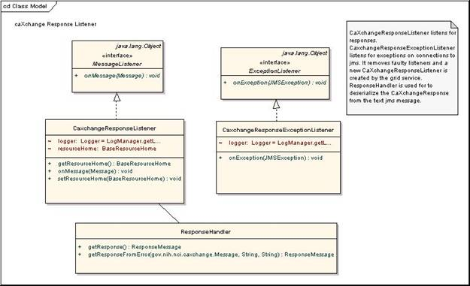
Figure 2 caXchange Response Listener
The caXchange service assembly is deployed on the Servicemix JBI container. The caXchange design diagram gives the detailed design of the caXchange service assembly.
Table 3 describes caXchange service assembly components. Numbers in the component column refer to the number in the caXchange design diagram given to an exchange going into that component.
Table 3 caXchange Service Assembly Components
Component | Type | Purpose
1. InboundComponent | JMS | Receive inbound caXchangeRequest messages.
3. Invoke Delegation Service | Bean/EIP (Enterprise Integration Patterns) | This includes two components, a pipeline, which invokes a bean component that calls delegation service for authentication and authorization.
3. 3/4.3 Response Generator | Bean | Generates an error response
4. Save Message | Bean/EIP | This includes two components, a pipeline, which invokes a bean component that saves the message to a database. The saved message is used to contruct a response and/or sends a rollback.
5. Content Based Router | EIP | Routes the message based on the message type to a particular static recipient list.
6. Static Recipient List | EIP Customized | Sends the message to multiple recipients for invoking target services. This is customized to add a message property for number of recipients. This is used to aggregate responses
7. Content Based Router | EIP | Routes message based on operation. If the operation is process the message is routed to a pipeline to invoke the service and get a response as an in-out message exchange. If the operation is rollback the message is send without expecting a response as an in-only message exchange.
8.1. Pipeline | EIP | Pipeline to invoke target service as an in-out message exchange.
8.2. Outbound Component | Bean | Outbound component that invokes the target Grid Service.
8.4. Aggregator | EIP Customized | Aggregator component aggregates responses from multiple target services. This is customized to work with the customized static recipient list in #6 above.
9. Aggregator Listener | Bean | Aggregated responses from the aggregator are forwarded to this component, which does two things. It looks at the response and the message type to verify if a rollback is required. If required a message with the rollback is sent to the content based router #5 after authentication and authorization by #3.It creates a caXchangeResponse and sends it to the jms outbound binding component.
10. ResponseComponent | JMS | Outbound caXchangeResponse are pushed to this component.

Sequence Diagrams

Successful Flow Sequence Diagram
The sequence for a successful flow through caXchange is depicted in Figure 3. Detailed flow through the caXchange service assembly is depicted in the caXchange design diagram.
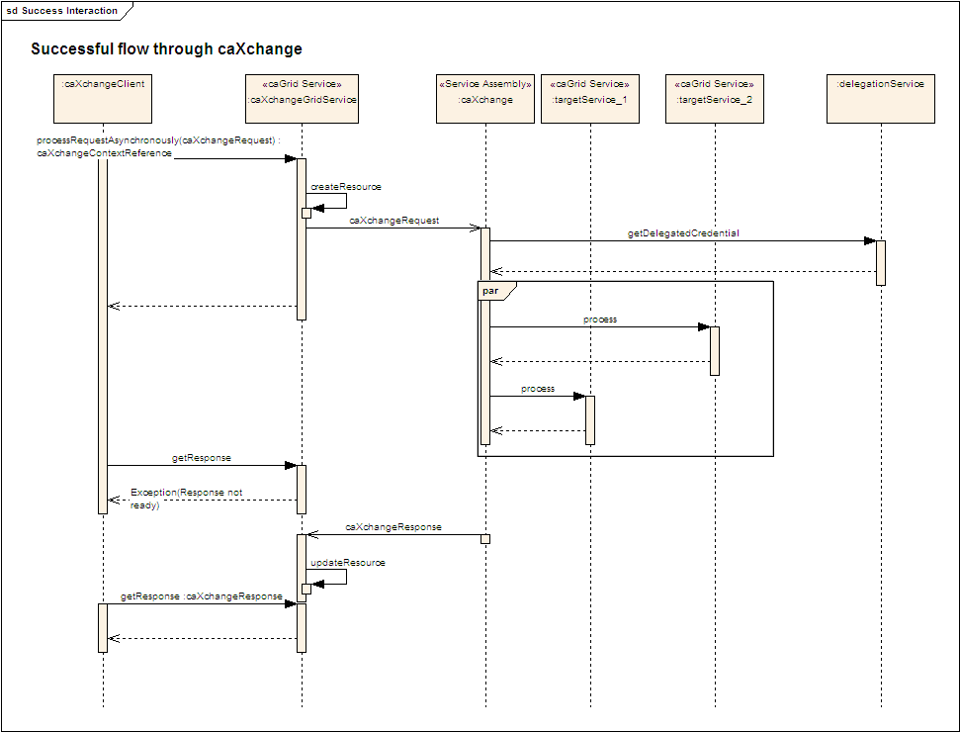
Figure 3 caXchange Successful Flow Sequence Diagram

Rollback Flow Sequence Diagram
The sequence for a rollback interaction with caXchange is depicted in Figure 4. Detailed interaction within the caXchange service assembly is depicted in the caXchange design diagram.
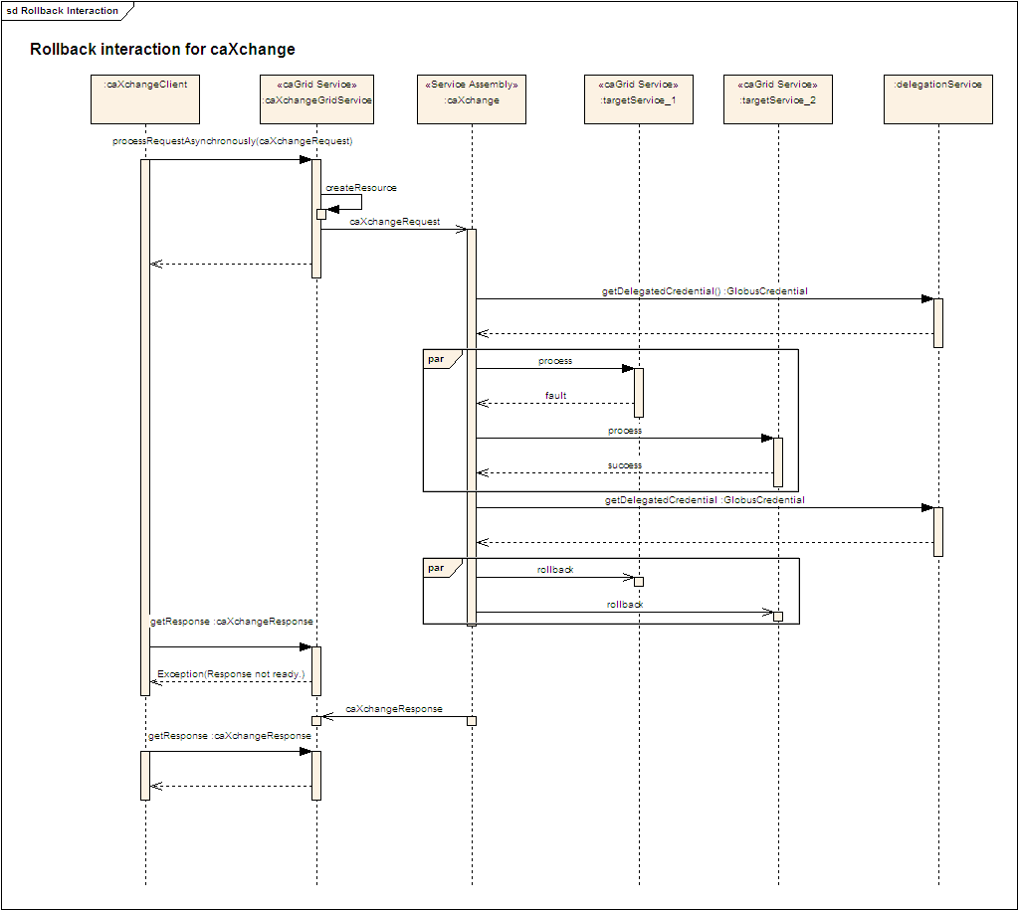
Figure 4 caXchange Rollback Interaction Sequence Diagram

Data
A database schema has been created to facilitate saving the inbound caXchange request message for sending rollbacks and for creating aggregated/error responses. The message is stored in the database table primarily for two reasons. To ensure that the message under processing within caXchange is not lost due to ESB or caXchange node or component failure, the message in its entirety is stored in the database table. Secondly as the message is processed within ESB framework, its metadata (such as grid credentials) are consumed and only the message payload remains in the memory. In case of the rollback the entire message, including metadata, is needed. In such an event the stored message is used to issue the rollback message.

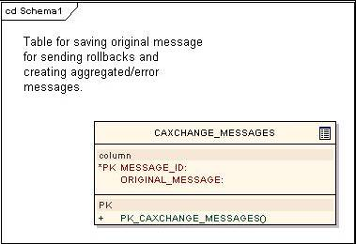
Figure 5 Database Table for caXchange Messages

Deployment
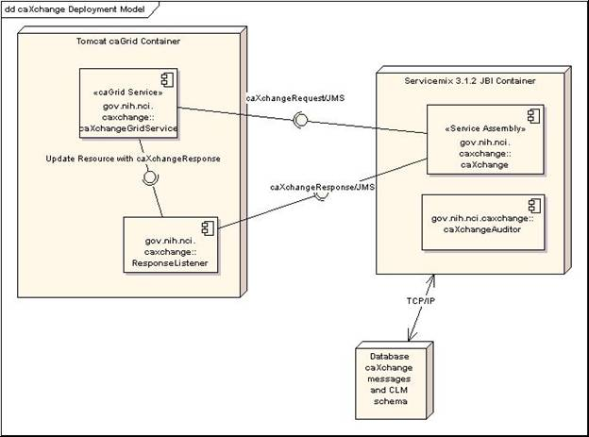
Figure 6 caXchange Deployment Model

Test Cases and Scenarios
Please refer to the caXchange Testing Approach Document for test cases.

Common Logging Module Integration

Requirements

Trace Message Flow Through caXchange
The user should be able to see the how a message was processed through caXchange.

Filter Messages to log by User
The user should have the ability to filter the messages they want to log.

Component View
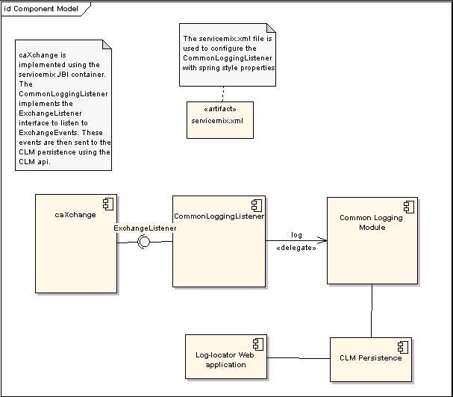
Figure 7 Component Model
- CommonLoggingListener registers with the caXchange Servicemix JBI Container to listen for all ExchangeEvents
- Servicemix JBI Container sends ExchangeEvents all registered ExchangeListeners ExchangeEvents.
- CommonLoggingListener logs the exchange events using the Common Logging Module.
- CommonLoggingListener can be configured using servicemix.xml with spring style configuration.

Local Design
The integration between CLM and caXchange has been achieved by implementing the ExchangeListener interface of servicemix. The CommonLoggingListener implements this interface. Additionally it adds properties to enable logging of messages meeting certain criteria. Each method of the ExchangeListener can be disabled using spring configuration in servicemix.xml. Additional String filters can be specified in this file, so that only messages matching those filters are logged.
The ExchangeListener interface has the following operations.
Table 4 ExchangeListener Interface Operations
Method | Notes | Parameters
public void exchangeSent(exchangeEvent), | Exchange listener interface. Receives messages from NMR before an exchange is sent. | ExchangeEvent exchangeEvent
public void exchangeAccpeted(exchangeEvent), | Exchange listener interface. Receives messages from NMR after an exchange is accepted. | ExchangeEvent exchangeEvent

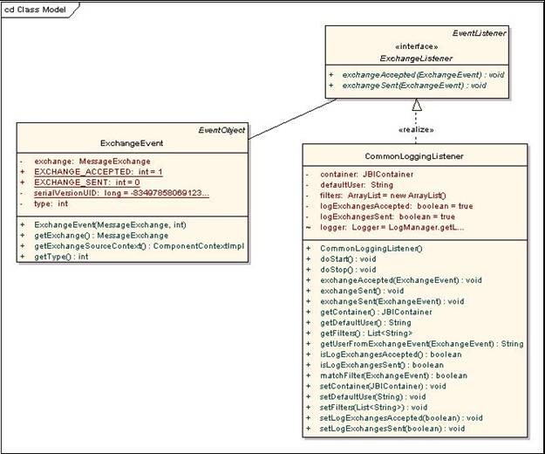
Figure 8 CLM Integration Class Model

Sequence Diagram
The sequence flow of a Successful Scenario is depicted in the following figure.

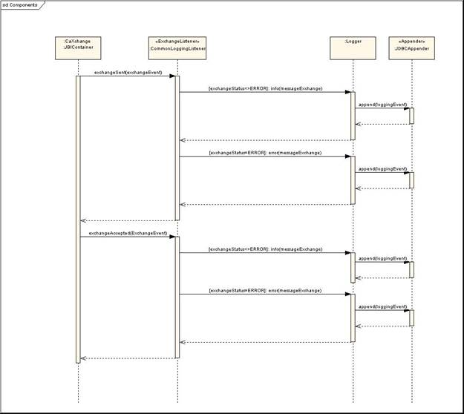
Figure 9 Logging and Auditing Successful Scenario Sequence Flow

Data
A separate CLM database has been created to facilitate logging and auditing for caXchange. Please refer to CLM LLT deployment Guide for more details about the schema.

Deployment
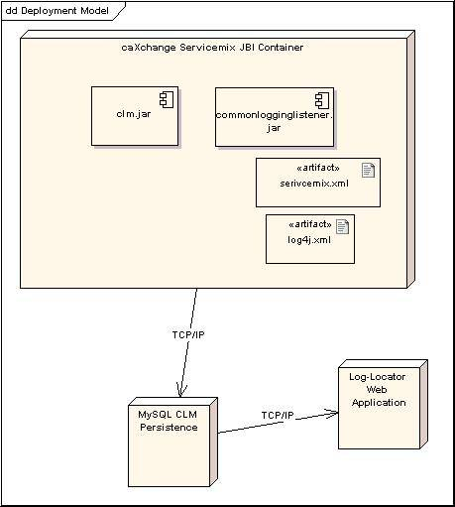
Figure 10 Common Logging Module Integration Deployment Model

Sample servicemix.xml configuration
<bean id="CLMLogger" class="gov.nih.nci.caxchange.servicemix.jbi.audit.CommonLoggingListener" init-method="doStart" >
<property name="container" ref="jbi" />
<property name="logExchangesSent" value="true" />
<property name="logExchangesAccepted" value="false" />
<property name="filters">
<list>
<value>Match</value>
</list>
</property>
</bean>

Test Cases and Scenarios
Please refer to the caXchangeTesting Approach Document for test cases.

Glossary
Term | Definition
NCICB | National Cancer Institute Center for Bioinformatics
BPEL | Business Process Execution Language
C3PR | Cancer Central Clinical Participant Registry
caAERS | Cancer Adverse Event Reporting System
GUID | A unique ID that the Enterprise Architect product assigns to each object that is created by the tool.
CCHC | Cancer Center Hub Client. The software that is responsible for sending patient laboratory data to the Lab Hub via an interface exposed by the HUB
Endpoint | A destination to which the hub can route data to. An endpoint can represent a service deployed on the hub or an external system to which the hub routes data.
CTMSI | Clinical Trials Management System Interoperability
CCTS | Cancer Clinical Trials Suite
CTODS | Clinical Trials Object Data System

caXchange Interface Specification
caXchange Interface Specification

